SRS
New purge-wipe cleaning process
For new Materials
for
Objet 3-D Printers
Connex machines family

Software Requirements Specification

 | Name | Date
Written by: | Avi Teken | 11/5/2010
Approved by:
Version No: | Version 3 | 27/5/2010

- Overview
This document defines the requirements for new purges - wipes sequences and new alert messages mechanism that is required for new Materials, for Objet 3-D printing Connex systems, it comprises requirements of all aspects of the machine software (EM).
- Objectives
To maintain the orifice plate from being dirty at the end of the printing and thus prevent the heads block from missing nozzles and increase the reliability.
  - To ensure manual cleaning by the user after at the most 100 printing hours when the user uses the new materials that required often cleaning.
- High level definitions
The new mechanism will be enabled per material type per printing mode as part of the embedded parameters new infrastructure.
  - All new Connex versions will include this additive. (57.1, 37.1, 28.1)
- Implementation
  - Standard purge and wipe sequence
    - Perform every 15 minutes purge and 5 wipes (Today the sequence performs 2 wipes but it is a parameter so nothing to do here)
  - Super purge
* A super purge is a new purge sequence that occur every XX hours of printing and contain special parameters of # of purges and # of wipes. This purge is aimed to clean residues of polymerized material from the orifice plate.
* Summary of the required new parameters located in the last section of this document.
    - Super purge will be implemented only during printings, that is, during wizards or other software sequences the super purge mechanism will be inactive.
    - Super purge will be implemented during printing every XX printing hours (Define new parameter) and will perform special amount of purges (Define new parameter) and special amount of wipes (Define new parameter).
    - A new parameter is required to enable activation of super purge at the end of printing. (Default value: Disabled)
    - Example 1:
1. The parameter of time between Super Purges = 15h.
2. First printing: 24h, Second printing: 5h, 3rd printing: 17h.
3. Super purge at the end of the printing is disabled.
According to those values, super purge will take place after:
1. After 15h during the first printing.
2. After 1h during the 3rd printing (And after 30h in total).
3. After 16h during the 3rd printing (And after 45h in total).
    - Example 2:
1. The parameter of time between Super Purges = 15h.
2. First printing: 24h, Second printing: 5h, 3rd printing: 17h.
3. Super purge at the end of the printing is enabled.
According to those values, super purge will take place after:
1. After 15h - during the first printing.
2. After 24h - at the end of the first printing.
3. After 5h - at the end of the second printing.
4. After 15h – during the 3rd printing
5. After 17h – at the end of the 3rd printing.
  - Super purge – messages
    - Add a new counter to the “Maintenance counters” to counts the time that has passed since the last activation of the “Heads Cleaning wizard”. This counter will count times between adjacent “Heads Cleaning wizards” no matter what type of material is loaded in the machine.
    - After activation of the “Heads Cleaning wizard” the counter will become zero, this include “Heads cleaning wizard” that is activated as part of the “Heads optimization wizard”.
    - History of the “Cleaning wizards” counter is not required.
    - Add a new parameter Y to define a timeout between messages to the user. (This parameter is related to messages #1, #2 and #3 as described below).
    - When Y printing hours are passed after the last activation of the “Heads cleaning wizard” a message will pop up (Message #1):
To ensure quality printing, you should clean the print heads.
Do you want to run the Head Cleaning wizard now?
Yes / No
    - This message will pop up at the beginning of the printing as a PRE print stage – it is important that the actual printing will not start yet at this stage!.
    - Two options will be available on the message body: “Yes”/ “No” – Pressing on the “Yes” button will open automatically the “Heads cleaning wizard” (The printing was not starting yet).
Pressing on the “No” button will close the message and the printing will start immediately.
    - When the user performs “Heads cleaning wizard” after the first message, the counter that count the time that has passed since the last activation of the “Cleaning heads wizard” will become equal to zero and a new counting will start.
    - When the user ignores the first message, the counting will continue and after 2Y hours (At the beginning of the following printing), a second message (Message #2) will pops up:
To ensure quality printing, you should clean the print heads now!
Run the Head Cleaning wizard?
Yes / No
    - When the user performs the “Heads cleaning wizard” after the second message, the counter that count the time that has passed since the last activation of the “Cleaning heads wizard” will become equal to zero and a new counting will start.
    - When the user ignores the message, the counting will continue and after 3Y hours (At the beginning of the following printing), a third message (Message #3) will pops up:
To prevent printing problems, you must clean the print heads before continuing.
If you click Yes, the Head Cleaning wizard will open.
If you click No, the print job will be cancelled.
Yes / No
    - After the third message, the user is must to perform “Heads cleaning wizard”, otherwise, he will not be able to start a new printing or to perform resume current printing.
    - When the user performs the “Heads cleaning wizard” after the third message, the counter that count the time that has passed since the last activation of the “Cleaning heads wizard” will become equal to zero and a new counting will start.
    - When the user ignores the third message by pressing on the “No” button, the printing will not start!
    - When the user performs MRW from non DLM material to DLM material, and the counter is <>0 the messages mechanism will refer to the value as if it was count with DLM material
Example:
VeroWhite is currently loaded in the machine and the “Heads cleaning wizard” counter is 70h.
The user performs MRW to DLM and doesn’t perform “Heads cleaning wizard” at this stage.
When the user will start the first DLM printing, a pop up message will appear with message #2 (Since message #2 pops up between 66h – 99h of non heads cleaning)
    - General:
For example: The value of the timeout between messages to the user is 33h
#1 message will pop up in the range between 33h - 66h → Y <> 2Y-1m (m= 1 Minute)
#2 message will pop up in the range between 66h - 99h → 2Y <> 3Y-1m (m= 1 Minute)
#3 message will pop up beyond 99h - → 3Y or more
    - Example:
1. The value of the timeout between messages to the user is 33h
2. After “Heads cleaning wizard”, first printing: 29h, second printing: 36h, third printing: 40h
3. The user does not perform heads cleaning wizards when he notified.
Message #1 will pop up at the beginning of the third printing, after accumulation of 65h (29+36)
Message #2 will not pop up at all.
Message #3 will pop up at the beginning of the 4th printing and the printing will be stopped. This happens after accumulation of 105h (29+36+40)
    - Flowchart:

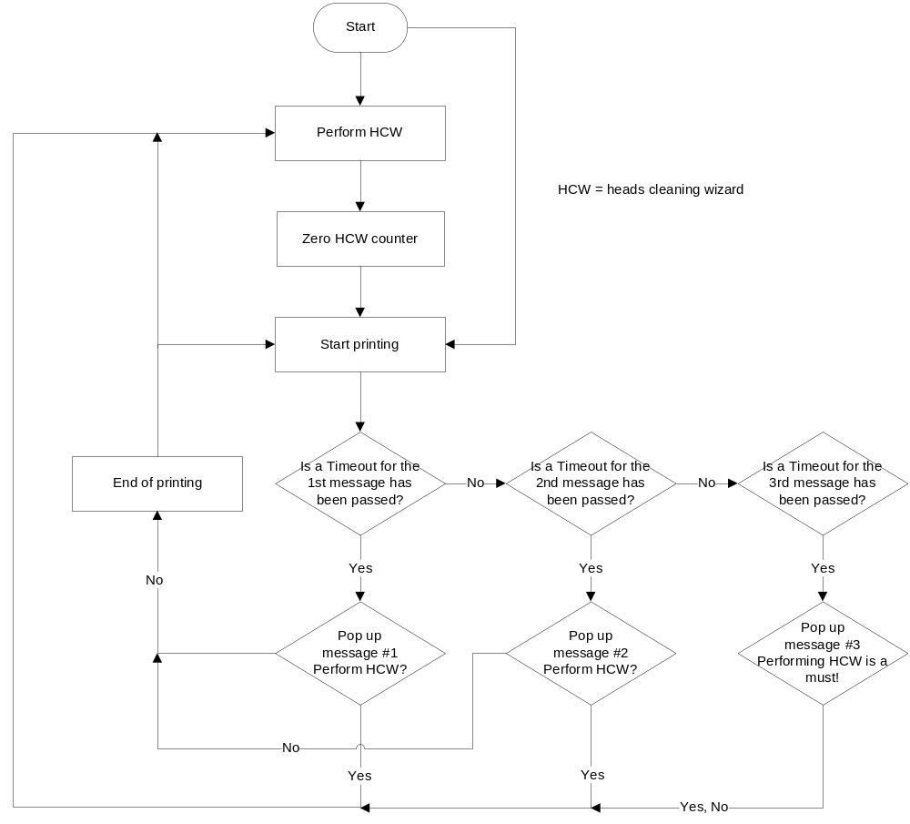

    - Description of the new required parameters (Summary):
      - Time Between Super Purges (In mintues)
      - Number of purges during Super Purge
      - Number of wipes during Super Purge
      - perform super purge at the end of printing (Checkbox)
      - Enable messages mechanism related to the super purge (Checkbox)
      - Timeout between adjacent heads cleaning wizards to issue a message to the user
      - Add a new counter (In the “Maintenance counters) that count the time that has passed since the last “Heads cleaning wizard’
      - After additional discussion with Eran Nave and Boris - we will ignore the minor influence of the Super Purge on the Objet Studio time and material estimations.
      - Add to the communication with the Host the time influences of 5 wipes (Standard wipe)
Currently, the Host is calculating ~ 40 sec per full sequence of 1x purge + 2x wipes. Now, the best way is to separate this parameter into 2 parameters: 1x purge and 1x wipe and the Host will calculate accordingly per the material that is loaded.
      - Additional requirement is needed in order to handle the required changes in Objet Studio version 9 (Connex systems). - TBD
    - Log files: Add the events of the super purge to the standard log file.
Name it differently in the log in order to distinguish between it and the standard purge.

